Level 3 Practice Programs
- Write a LeapYear program that takes a year as input and outputs the Year is a Leap Year or not a Leap Year.
- The LeapYear program only works for year >= 1582, corresponding to a year in the Gregorian calendar. So ensure to check for the same.
- Further, the Leap Year is a Year divisible by 4 and not 100 unless it is divisible by 400. E.g. 1800 is not a Leap Year and 2000 is a Leap Year.
- Write code having multiple if else statements based on conditions provided above and a second part having only one if statement and multiple logical
Source Code:
import java.util.Scanner;
public class LeapYear {
public static void main(String[] args) {
Scanner scanner = new Scanner(System.in);
System.out.print("Enter a year: ");
int year = scanner.nextInt();
// Check if the year is valid (Gregorian calendar started in 1582)
if (year >= 1582) {
// Leap year condition: divisible by 4
if (year % 4 == 0) {
// Not a leap year if divisible by 100, unless also divisible by 400
if (year % 100 == 0) {
if (year % 400 == 0) {
System.out.println(year + " is a Leap Year.");
} else {
System.out.println(year + " is NOT a Leap Year.");
}
} else {
System.out.println(year + " is a Leap Year.");
}
} else {
System.out.println(year + " is NOT a Leap Year.");
}
} else {
System.out.println("Invalid input! Leap Year calculations start from 1582.");
}
}
}
- Rewrite program 1 to determine Leap Year with single if condition using logical and && and or || operators
Source Code:
import java.util.Scanner;

public class LeapYearLogical {
public static void main(String[] args) {
Scanner scanner = new Scanner(System.in);
System.out.print("Enter a year: ");
int year = scanner.nextInt();

// Check if the year follows leap year rules using a single condition
if (year >= 1582 && (year % 4 == 0 && year % 100 != 0 || year % 400 == 0)) {
System.out.println(year + " is a Leap Year.");
} else {
System.out.println(year + " is NOT a Leap Year.");
}
}
}

- Write a program to input marks and 3 subjects physics, chemistry and maths. Compute the percentage and then calculate the grade as per the following guidelines
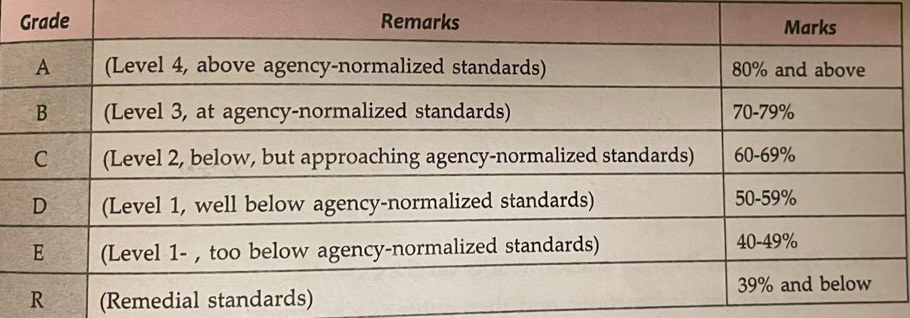
Hint =>
- Ensure the Output clearly shows the Average Mark as well as the Grade and Remarks
Source Code:
import java.util.Scanner;

public class StudentGrade {
public static void main(String[] args) {
Scanner scanner = new Scanner(System.in);

// Taking input for three subjects
System.out.print("Enter marks in Physics: ");
int physics = scanner.nextInt();
System.out.print("Enter marks in Chemistry: ");
int chemistry = scanner.nextInt();
System.out.print("Enter marks in Maths: ");
int maths = scanner.nextInt();

// Calculate average marks
double average = (physics + chemistry + maths) / 3.0;
System.out.println("Average Marks: " + average);

// Assign grades based on average marks
if (average >= 90) {
System.out.println("Grade: A (Excellent)");
} else if (average >= 75) {
System.out.println("Grade: B (Very Good)");
} else if (average >= 60) {
System.out.println("Grade: C (Good)");
} else if (average >= 40) {
System.out.println("Grade: D (Pass)");
} else {
System.out.println("Grade: F (Fail)");
}
}
}

- Write a Program to check if the given number is a prime number or not
Hint =>
- A number that can be divided exactly only by itself and 1 are Prime Numbers,
- Prime Numbers checks are done for number greater than 1
- Loop through all the numbers from 2 to the user input number and check if the reminder is zero. If the reminder is zero break out from the loop as the number is divisible by some other number and is not a prime number.
- Use isPrime boolean variable to store the result
Source Code:
import java.util.Scanner;

public class PrimeNumber {
public static void main(String[] args) {
Scanner scanner = new Scanner(System.in);
System.out.print("Enter a number: ");
int num = scanner.nextInt();

// Assume the number is prime unless proven otherwise
boolean isPrime = num > 1;

// Check divisibility from 2 to sqrt(num)
for (int i = 2; i <= Math.sqrt(num); i++) {
if (num % i == 0) {
isPrime = false; // Not prime if divisible
break;
}
}

// Print result
System.out.println(num + " is " + (isPrime ? "a Prime Number." : "NOT a Prime Number."));
}
}

- Create a program to check if a number is armstrong or not. Use the hints to show the steps clearly in the code
Hint =>
- Armstrong Number is a number whose Sum of cubes of each digit results in the original number as in for e.g. 153 = 1^3 + 5^3 + 3^3
- Get an integer input and store it in the number variable and define sum variable, initialize it to zero and originalNumber variable and assign it to input number variable
- Use the while loop till the originalNumber is not equal to zero
- In the while loop find the reminder number by using the modulus operator as in number % 10. Find the cube of the number and add it to the sum variable
- Again in while loop find the quotient of the number and assign it to the original number using number / 10 expression. This romoves the last digit of the original number.
- Finally check if the number and the sum are the same, if same its an Armstrong number else not. So display accordingly
Source Code:
import java.util.Scanner;

public class ArmstrongNumber {
public static void main(String[] args) {
Scanner scanner = new Scanner(System.in);
System.out.print("Enter a number: ");
int num = scanner.nextInt();
int originalNum = num, sum = 0;

// Calculate sum of cubes of each digit
while (num > 0) {
int digit = num % 10;
sum += Math.pow(digit, 3);
num /= 10;
}

// Compare sum with the original number
System.out.println(originalNum + " is " + (sum == originalNum ? "an Armstrong Number." : "NOT an Armstrong Number."));
}
}

- Create a program to count the number of digits in an integer.
Hint =>
- Get an integer input for the number variable.
- Create an integer variable count with value 0.
- Use a loop to iterate until number is not equal to 0.
- Remove the last digit from number in each iteration
- Increase count by 1 in each iteration.
- Finally display the count to show the number of digits
Source Code:
import java.util.Scanner;

public class CountDigits {
public static void main(String[] args) {
Scanner scanner = new Scanner(System.in);
System.out.print("Enter a number: ");
int num = scanner.nextInt();
int count = 0;

// Count the digits by dividing num by 10 repeatedly
while (num != 0) {
num /= 10;
count++;
}

System.out.println("Number of digits: " + count);
}
}

- Create a program to find the BMI of a person
- Take user input in double for the weight (in kg) of the person and height (in cm) for the person and store it in the corresponding variable.
- Use the formula BMI = weight / (height * height). Note unit is kg/m^2. For this convert cm to meter
- Use the table to determine the weight status of the person
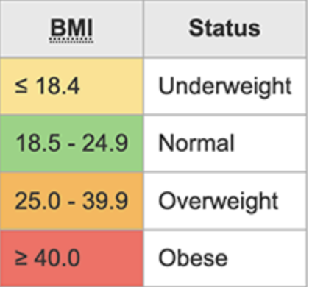
Source Code:
import java.util.Scanner;
public class BMICalculator {
public static void main(String[] args) {
Scanner scanner = new Scanner(System.in);
System.out.print("Enter weight (kg): ");
double weight = scanner.nextDouble();
System.out.print("Enter height (cm): ");
double height = scanner.nextDouble() / 100; // Convert cm to meters
// Calculate BMI
double bmi = weight / (height * height);
System.out.println("BMI: " + bmi);
// Determine BMI category
if (bmi < 18.5) {
System.out.println("Underweight");
} else if (bmi < 24.9) {
System.out.println("Normal weight");
} else if (bmi < 29.9) {
System.out.println("Overweight");
} else {
System.out.println("Obese");
}
}
}
- Create a program to check if a number taken from the user is a Harshad Number.
Hint =>
- A Harshad number is an integer which is divisible by the sum of its digits.
For example, 21 which is perfectly divided by 3 (sum of digits: 2 + 1).
- Get an integer input for the number variable.
- Create an integer variable sum with initial value 0.
- Create a while loop to access each digit of the number.
- Inside the loop, add each digit of the number to sum.
- Check if the number is perfectly divisible by the sum.
- If the number is divisible by the sum, print Harshad Number. Otherwise, print Not a Harshad Number.
Source Code:
import java.util.Scanner;

public class HarshadNumber {
public static void main(String[] args) {
Scanner scanner = new Scanner(System.in);
System.out.print("Enter a number: ");
int num = scanner.nextInt();
int sum = 0, originalNum = num;

// Sum up the digits
while (num > 0) {
sum += num % 10;
num /= 10;
}

// Check divisibility
System.out.println(originalNum + " is " + (originalNum % sum == 0 ? "a Harshad Number." : "NOT a Harshad Number."));
}
}

- Create a program to check if a number is an Abundant Number.
Hint =>
- An abundant number is an integer in which the sum of all the divisors of the number is greater than the number itself. For example,
Divisor of 12: 1, 2, 3, 4, 6
Sum of divisor: 1 + 2 + 3 + 4 + 6 = 16 > 12
- Get an integer input for the number variable.
- Create an integer variable sum with initial value 0.
- Run a for loop from i = 1 to i < number.
- Inside the loop, check if number is divisible by i.
- If true, add i to sum.
- Outside the loop Check if sum is greater than number.
- If the sum is greater than the number, print Abundant Number. Otherwise, print Not an Abundant Number.
Source Code:
import java.util.Scanner;

public class AbundantNumber {
public static void main(String[] args) {
Scanner scanner = new Scanner(System.in);
System.out.print("Enter a number: ");
int num = scanner.nextInt();
int sum = 0;

// Sum of divisors
for (int i = 1; i < num; i++) {
if (num % i == 0) {
sum += i;
}
}

// Check if sum of divisors is greater than the number
System.out.println(num + " is " + (sum > num ? "an Abundant Number." : "NOT an Abundant Number."));
}
}

- Write a program to create a calculator using switch...case.
Hint =>
- Create two double variables named first and second and a String variable named op.
- Get input values for all variables.
- The input for the operator can only be one of the four values: "+", "-", "*" or "/".
- Run a for loop from i = 1 to i < number.
- Based on the input value of the op, perform specific operations using the switch...case statement and print the result.
- If op is +, perform addition between first and second; if it is -, perform subtraction and so on.
- If op is neither of those 4 values, print Invalid Operator.
Source Code:
import java.util.Scanner;

public class Calculator {
public static void main(String[] args) {
Scanner scanner = new Scanner(System.in);

// Taking two numbers as input
System.out.print("Enter first number: ");
double first = scanner.nextDouble();

System.out.print("Enter second number: ");
double second = scanner.nextDouble();

// Taking operator input
System.out.print("Enter an operator (+, -, *, /): ");
char op = scanner.next().charAt(0);

double result;

// Using switch-case to perform the required operation
switch (op) {
case '+':
result = first + second;
System.out.println("Result: " + result);
break;
case '-':
result = first - second;
System.out.println("Result: " + result);
break;
case '*':
result = first * second;
System.out.println("Result: " + result);
break;
case '/':
// Checking if the denominator is not zero to avoid division by zero error
if (second != 0) {
result = first / second;
System.out.println("Result: " + result);
} else {
System.out.println("Error! Division by zero is not allowed.");
}
break;
default:
// If the operator is invalid
System.out.println("Invalid operator! Please enter +, -, *, or /.");
}

scanner.close();
}
}

- Write a program DayOfWeek that takes a date as input and prints the day of the week that the date falls on. Your program should take three command-line arguments: m (month), d (day), and y (year). For m use 1 for January, 2 for February, and so forth. For output print 0 for Sunday, 1 for Monday, 2 for Tuesday, and so forth. Use the following formulas, for the Gregorian calendar (where / denotes integer division):
y₀ = y − (14 − m) / 12
x = y₀ + y₀/4 − y₀/100 + y₀/400
m₀ = m + 12 × ((14 − m) / 12) − 2
d₀ = (d + x + 31m₀ / 12) mod 7
Source Code:
import java.util.Scanner;

public class DayOfWeek {
public static void main(String[] args) {
Scanner scanner = new Scanner(System.in);

// Taking input for day, month, and year
System.out.print("Enter day: ");
int d = scanner.nextInt();

System.out.print("Enter month: ");
int m = scanner.nextInt();

System.out.print("Enter year: ");
int y = scanner.nextInt();

// Formula for calculating the day of the week
int y0 = y - (14 - m) / 12; // Adjust the year based on the month
int x = y0 + y0 / 4 - y0 / 100 + y0 / 400; // Leap year adjustments
int m0 = m + 12 * ((14 - m) / 12) - 2; // Adjust the month value
int d0 = (d + x + (31 * m0) / 12) % 7; // Compute day of the week (0=Sunday, 1=Monday,...)

// Displaying the day of the week
String[] days = {"Sunday", "Monday", "Tuesday", "Wednesday", "Thursday", "Friday", "Saturday"};
System.out.println("The day of the week is: " + days[d0]);

scanner.close();
}
}

